Alzheimer Disease Prediction using Machine Learning Algorithms
1. INTRODUCTION
Alzheimer disease is caused by both genetic and environmental factors, those affects the brain of a person over time. The genetic changes guarantee a person will develop this disease. This disease breaks the brain tissue over time. It occurs to people over age 65. However people live with this disease for about 9 years and about 1 among 8 people of age 65 and over have this disease. MMSE (Mini Mental State Examination) score is the main parameter used for prediction of the disease. This score reduces periodically if the person is affected. Those people having MCI have a serious risk of growing dementia. When the fundamental MCI results in a loss of memory, the situation expects to develop to dementia due to this kind of disease. There is no treatment to cure Alzheimer's disease. In advanced stages of the disease, complications like dehydration, malnutrition or infection occurs which leads to death. The diagnosis at MCI stage will help the person to focus on healthy approach of life, and good planning to take care of memory loss
1.1 Objective of the Project
Alzheimer disease is the one amongst neurodegenerative disorders. Though the symptoms are benign initially, they become more severe over time. Alzheimer's disease is a prevalent sort of dementia. This disease is challenging one because there is no treatment for the disease. Diagnosis of the disease is done but that too at the later stage only. Thus if the disease is predicted earlier, the progression or the symptoms of the disease can be slow down. This paper uses machine learning algorithms to predict the Alzheimer disease using psychological parameters like age, number of visit, MMSE and education.
2. LITERATURE SURVEY
“Multistage classifier-based approach for Alzheimer’s Disease prediction and retrieval”,
The most prevalent and common type of dementia is Alzheimer's disease (AD). However, it is notable that very few people who are suffering from AD are diagnosed correctly and in a timely manner. The definite cause and cure of the disease are still unavailable. The symptoms might be more manageable and its treatment can be more effective, when the impairment is still at an earlier stage or at MCI (mild cognitive impairment). AD can be clinically diagnosed by physical and neurological examination, so there is an need for developing better and efficient diagnostic tools for AD. In recent years, content-based image retrieval (CBIR) systems have been widely researched and applied in many medical applications. Combining an automated image classification system and the radiologist's professional knowledge, to increase the accuracy of prediction and diagnosis, were the main motives. In this paper, a multistage classifier using machine learning, including Naive Bayes classifier, support vector machine (SVM), and K-nearest neighbor (KNN), was used to classify Alzheimer's disease more acceptably and efficiently. For this, MRI (Magnetic resonance imaging) scans were processed by FreeSurfer, a powerful software tool suitable for processing and normalizing brain MRI images. We also applied a feature selection technique - PSO (particle swarm optimization) to many feature vectors in order to obtain the best features that represent the salient characteristics of AD. The results of the proposed method outperform individual techniques in a benchmark database provided by the Alzheimer's Disease Neuroimaging Institute (ADNI).
“Early Diagnosis of Alzheimer’s Disease Based on Resting-State Brain Networks and Deep Learning”,
Computerized healthcare has undergone rapid development thanks to the advances in medical imaging and machine learning technologies. Especially, recent progress on deep learning opens a new era for multimedia based clinical decision support. In this paper, we use deep learning with brain network and clinical relevant text information to make early diagnosis of Alzheimer's Disease (AD). The clinical relevant text information includes age, gender, and ApoE gene of the subject. The brain network is constructed by computing the functional connectivity of brain regions using resting-state functional magnetic resonance imaging (R-fMRI) data. A targeted autoencoder network is built to distinguish normal aging from mild cognitive impairment, an early stage of AD. The proposed method reveals discriminative brain network features effectively and provides a reliable classifier for AD detection. Compared to traditional classifiers based on R-fMRI time series data, about 31.21 percent improvement of the prediction accuracy is achieved by the proposed deep learning method, and the standard deviation reduces by 51.23 percent in the best case that means our prediction model is more stable and reliable compared to the traditional methods. Our work excavates deep learning's advantages of classifying high-dimensional multimedia data in medical services, and could help predict and prevent AD at an early stage.
“RNN-based longitudinal analysis for diagnosis of Alzheimer’s disease”,
Alzheimer's disease (AD) is an irreversible neurodegenerative disorder with progressive impairment of memory and other mental functions. Magnetic resonance images (MRI) have been widely used as an important imaging modality of brain for AD diagnosis and monitoring the disease progression. The longitudinal analysis of sequential MRIs is important to model and measure the progression of the disease along the time axis for more accurate diagnosis. Most existing methods extracted the features capturing the morphological abnormalities of brain and their longitudinal changes using MRIs and then designed a classifier to discriminate different groups. However, these methods have several limitations. First, since the feature extraction and classifier model are independent, the extracted features may not capture the full characteristics of brain abnormalities related to AD. Second, longitudinal MR images may be missing at some time points for some subjects, which results in difficulties for extraction of consistent features for longitudinal analysis. In this paper, we present a classification framework based on combination of convolutional and recurrent neural networks for longitudinal analysis of structural MR images in AD diagnosis. First, Convolutional Neural Networks (CNN) is constructed to learn the spatial features of MR images for the classification task. After that, recurrent Neural Networks (RNN) with cascaded three bidirectional gated recurrent units (BGRU) layers is constructed on the outputs of CNN at multiple time points for extracting the longitudinal features for AD classification. Instead of independently performing feature extraction and classifier training, the proposed method jointly learns the spatial and longitudinal features and disease classifier, which can achieve optimal performance. In addition, the proposed method can model the longitudinal analysis using RNN from the imaging data at various time points. Our method is evaluated with the longitudinal T1-weighted MR images of 830 participants including 198 AD, 403 mild cognitive impairment (MCI), and 229 normal controls (NC) subjects from Alzheimer's Disease Neuroimaging Initiative (ADNI) database. Experimental results show that the proposed method achieves classification accuracy of 91.33% for AD vs. NC and 71.71% for pMCI vs. sMCI, demonstrating the promising performance for longitudinal MR image analysis.
“Multi-modal deep learning model for auxiliary diagnosis of Alzheimer’s disease”,
Alzheimer’s disease (AD) is one of the most difficult to cure diseases. Alzheimer’s disease seriously affects the normal lives of the elderly and their families. The mild cognitive impairment (MCI) is a transitional state between the normal aging and Alzheimer’s disease, and MCI is most likely to converted to AD later. MCI is often misdiagnosed as the symptoms of normal aging, which results to miss the best opportunity of treatment. Therefore, the accurate diagnosis of MCI is essential for the early diagnosis and treatment of AD. This paper presents a deep learning model for the auxiliary diagnosis of AD, which simulates the clinician’s diagnostic process. During the diagnosis of AD, clinician usually refers to the results of various neuroimaging, as well as the results of neuropsychological diagnosis. In this paper, the multi-modal medical images are trained by two independent convolutional neural networks. Then the consistency of the output of two convolutional neural networks is judged by the correlation analysis. Finally, the results of multi-modal neuroimaging diagnosis are combined with the results of clinical neuropsychological diagnosis. The proposed model provides a comprehensive analysis about patient’s pathology and psychology at the same time, therefore, it improves the accuracy of auxiliary diagnosis. The diagnosis process is closer to the process of clinician’s diagnosis and easy to implement. Experiments on the public database of ADNI (Alzheimer’s disease neuroimaging initiative) show that the proposed method has better performance, and can achieve an excellent diagnostic efficiency in the auxiliary diagnosis of AD.
“Multi-stream multi-scale deep convolutional networks for Alzheimer’s disease detection using MR images”,
This paper addresses the issue of Alzheimer’s disease (AD) detection from Magnetic Resonance Images (MRIs). Existing AD detection methods rely on global feature learning from the whole brain scans, while depending on the tissue types, AD related features in different tissue regions, e.g. grey matter (GM), white matter (WM), and cerebrospinal fluid (CSF), show different characteristics. In this paper, we propose a deep learning method for multi-scale feature learning based on segmented tissue areas. A novel deep 3D multi-scale convolutional network scheme is proposed to generate multi-resolution features for AD detection. The proposed scheme employs several parallel 3D multi-scale convolutional networks, each applying to individual tissue regions (GM, WM and CSF) followed by feature fusions. The proposed fusion is applied in two separate levels: the first level fusion is applied on different scales within the same tissue region, and the second level is on different tissue regions. To further reduce the dimensions of features and mitigate overfitting, a feature boosting and dimension reduction method, XGBoost, is utilized before the classification. The proposed deep learning scheme has been tested on a moderate open dataset of ADNI (1198 scans from 337 subjects), with excellent test performance on randomly partitioned datasets (best 99.67%, average 98.29%), and good test performance on subject-separated partitioned datasets (best 94.74%, average 89.51%). Comparisons with state-of-the-art methods are also included.
"Multimodal neuroimaging feature learning with multimodal stacked deep polynomial networks for diagnosis of Alzheimer’s disease"
The accurate diagnosis of Alzheimer's disease (AD) and its early stage, i.e., mild cognitive impairment, is essential for timely treatment and possible delay of AD. Fusion of multimodal neuroimaging data, such as magnetic resonance imaging (MRI) and positron emission tomography (PET), has shown its effectiveness for AD diagnosis. The deep polynomial networks (DPN) is a recently proposed deep learning algorithm, which performs well on both large-scale and small-size datasets. In this study, a multimodal stacked DPN (MM-SDPN) algorithm, which MM-SDPN consists of two-stage SDPNs, is proposed to fuse and learn feature representation from multimodal neuroimaging data for AD diagnosis. Specifically speaking, two SDPNs are first used to learn high-level features of MRI and PET, respectively, which are then fed to another SDPN to fuse multimodal neuroimaging information. The proposed MM-SDPN algorithm is applied to the ADNI dataset to conduct both binary classification and multiclass classification tasks. Experimental results indicate that MM-SDPN is superior over the state-of-the-art multimodal feature-learning-based algorithms for AD diagnosis.
“CSF biomarkers of Alzheimer’s disease concord with amyloid-pet and predict clinical progression: A study of fully automated immunoassays in Bio FINDER and ADNI cohorts”
Alzheimer\'s disease (AD) is one of the most common neurodegenerative diseases and is considered to be the main cause of cognitive impairment in elderly people. It is a progressive disease that destroys memory and other important mental functions and causes problems with memory, thinking and behavior. Symptoms usually develop slowly and worsen over time Symptoms may become severe enough to interfere with daily life, and lead to death. In 2022, 55 million people worldwide suffered from this disease. AD is predicted to affect 1 in 85 people globally by 2050, and at least 43% of prevalent cases need a high level of care. Alzheimer\'s Disease Neuroimaging Initiative (ADNI) give datasets that can be utilized for different Alzheimer\'s Disease related examinations. The dataset consists of a longitudinal MRI data of 150 subjects aged 60 to 96.72 of the subjects were grouped as \'Nondemented\' throughout the study.64 of the subjects were grouped as \'Demented\' at the time of their initial visits and remained so throughout the study.14 subjects were grouped as \'Nondemented\' at the time of their initial visit and were subsequently characterized as \'Demented\' at a later visit. These fall under the \'Converted\' category. In our project, we propose some machine learning models to detect the Alzheimer\'s disease in earlier stage by finding the accuracy levels and determining the attributes that helps us to find the maximum accuracy rate.
“Combining Polygenic Hazard Score With Volumetric MRI and Cognitive Measures Improves Prediction of Progression from Mild Cognitive Impairment to Alzheimer’s Disease”
Improved prediction of progression to Alzheimer's Disease (AD) among older individuals with mild cognitive impairment (MCI) is of high clinical and societal importance. We recently developed a polygenic hazard score (PHS) that predicted age of AD onset above and beyond APOE. Here, we used data from the Alzheimer's Disease Neuroimaging Initiative (ADNI) to further explore the potential clinical utility of PHS for predicting AD development in older adults with MCI. We examined the predictive value of PHS alone and in combination with baseline structural magnetic resonance imaging (MRI) data on performance on the Mini-Mental State Exam (MMSE). In survival analyses, PHS significantly predicted time to progression from MCI to AD over 120 months (p = 1.07e-5), and PHS was significantly more predictive than APOE alone (p = 0.015). Combining PHS with baseline brain atrophy score and/or MMSE score significantly improved prediction compared to models without PHS (three-factor model p = 4.28e-17). Prediction model accuracies, sensitivities and area under the curve were also improved by including PHS in the model, compared to only using atrophy score and MMSE. Further, using linear mixed-effect modeling, PHS improved the prediction of change in the Clinical Dementia Rating-Sum of Boxes (CDR-SB) score and MMSE over 36 months in patients with MCI at baseline, beyond both APOE and baseline levels of brain atrophy. These results illustrate the potential clinical utility of PHS for assessment of risk for AD progression among individuals with MCI both alone, or in conjunction with clinical measures of prodromal disease including measures of cognitive function and regional brain atrophy.
“A clinically-translatable machine learning algorithm for the prediction of Alzheimer's disease conversion: further evidence of its accuracy via a transfer learning approach”
Background: Available therapies for Alzheimer's disease (AD) can only alleviate and delay the advance of symptoms, with the greatest impact eventually achieved when provided at an early stage. Thus, early identification of which subjects at high risk, e.g., with MCI, will later develop AD is of key importance. Currently available machine learning algorithms achieve only limited predictive accuracy or they are based on expensive and hard-to-collect information. Objective: The current study aims to develop an algorithm for a 3-year prediction of conversion to AD in MCI and PreMCI subjects based only on non-invasively and effectively collectable predictors. Methods: A dataset of 123 MCI/PreMCI subjects was used to train different machine learning techniques. Baseline information regarding sociodemographic characteristics, clinical and neuropsychological test scores, cardiovascular risk indexes, and a visual rating scale for brain atrophy was used to extract 36 predictors. Leave-pair-out-cross-validation was employed as validation strategy and a recursive feature elimination procedure was applied to identify a relevant subset of predictors. Results: 16 predictors were selected from all domains excluding sociodemographic information. The best model resulted a support vector machine with radial-basis function kernel (whole sample: AUC = 0.962, best balanced accuracy = 0.913; MCI sub-group alone: AUC = 0.914, best balanced accuracy = 0.874). Conclusions: Our algorithm shows very high cross-validated performances that outperform the vast majority of the currently available algorithms, and all those which use only non-invasive and effectively assessable predictors. Further testing and optimization in independent samples will warrant its application in both clinical practice and clinical trials
“Blood-brain barrier breakdown is an early biomarker of human cognitive dysfunction”,
Vascular contributions to cognitive impairment are increasingly recognized1,2,3,4,5 as shown by neuropathological ,neuroimaging, and cerebrospinal fluid biomarker4,12 studies. Moreover, small vessel disease of the brain has been estimated to contribute to approximately 50% of all dementias worldwide, including those caused by Alzheimer’s disease (AD). Vascular changes in AD have been typically attributed to the vasoactive and/or vasculotoxic effects of amyloid , and more recently tau. Animal studies suggest that Aβ and tau lead to blood vessel abnormalities and blood–brain barrier (BBB) breakdown. Although neurovascular dysfunction and BBB breakdown develop early in AD, how they relate to changes in the AD classical biomarkers Aβ and tau, which also develop before dementia17, remains unknown. To address this question, we studied brain capillary damage using a novel cerebrospinal fluid biomarker of BBB-associated capillary mural cell pericyte, soluble platelet-derived growth factor receptor-β, and regional BBB permeability using dynamic contrast-enhanced magnetic resonance imaging. Our data show that individuals with early cognitive dysfunction develop brain capillary damage and BBB breakdown in the hippocampus irrespective of Alzheimer’s Aβ and/or tau biomarker changes, suggesting that BBB breakdown is an early biomarker of human cognitive dysfunction independent of Aβ and tau.
3. SYSTEM ANALYSIS
3.1 Existing System:
Among neurodegenerative diseases, Alzheimer's is the most common. Despite being mild at first, the symptoms eventually become debilitating. Alzheimer's disease is one of the most common forms of dementia. The lack of a cure for this illness makes it a difficult problem to solve. Unfortunately, the illness is usually typically diagnosed late in its course.
Disadvantage
- Time Taking
- Less Accuracy
3.2 Proposed System:
Support Vector Machine SVM is directed study model that classifies by separating the objects using a hyper plane. It can be used for both classification and regression. The hyper planes are drawn with the help of the margins. The main goal is to maximize the distance between the hyper plane and the margin. The margins are drawn with the help of support vectors that are belonging to the objects. The main advantage of SVM is that it can distinguish linear and non-linear objects. the steps in predicting the Alzheimer disease using machine learning algorithms. The required packages for SVM classifier in R are caret and e1071 packages. The formula consists of the fields that are considered for prediction. The basic type c-classification and linear kernel is chosen. They both mostly depend on the data used.. It can solve any type and variety of problems. It can also be used for both classification and regression. A small change in the data also can give a great impact on the output. Decision Tree Decision tree is a supervised learning model that uses a set of rules to find a solution. It can solve any type and variety of problems. It can also be used for both classification and regression. A small change in the data also can give a great impact on the output. For a continuous variable regression trees can be used and for categorical variable classification trees can be used
Advantage
  - It reduces the time required to predict the output
  - High Accuracy
  - The proposed approach detects the various stages of Alzheimer’s Disease
  - Build, deploy, and scale ML models faster.
  - It gives 99.9%.
  - Support Vector Machine 85%
  - Decision Tree 83%
Modules Description
To implement this project we have designed following modules
- Upload Alzheimer Disease Dataset: using this module we will upload dataset to application
- Dataset Preprocessing: using this module we will read dataset and then encode non-numeric values in above dataset to numeric and then replace missing values with 0 and then split dataset into train and test part where application used 80% dataset for training and 20% for testing
- Run SVM Algorithm: using this module we will train SVM with 80% training data and then calculate its accuracy by predicting 20% test data
- Run Decision Tree Algorithm: using this module we will train decision tree with 80% training data and then calculate its accuracy by predicting 20% test data
- Comparison Graph: using this module we will plot accuracy comparison graph between all algorithms
- Predict Disease from Test Data: using this module we will upload test and then machine learning algorithm will predict weather test data is normal or contains Alzheimer symptoms

Analysis of Women Safety in Indian Cities Using Machine Learning on Tweets

FUNCTIONAL REQUIREMENTS:
SOFTWARE REQIREMENTS:
System Attributes:
filename, dataset
- X, Y
- error
- le1, le2, le3
- X_train, X_test, y_train, y_test, classifier

Data base Requirements:
No need
USECASE:
- Use cases - Use cases describe the interaction between the system and external users that leads to achieving particular goals.
- Each use case includes main elements:
- Upload Alzheimer Disease Dataset
- Dataset Pre-processing
- Run SVM Algorithm
- Run Decision Tree Algorithm
- Comparison Graph
- Predict Disease from Test Data
User Stories: we are training SVM and Decision tree algorithms and then comparing their performance in terms of accuracy.
Work down Structure:
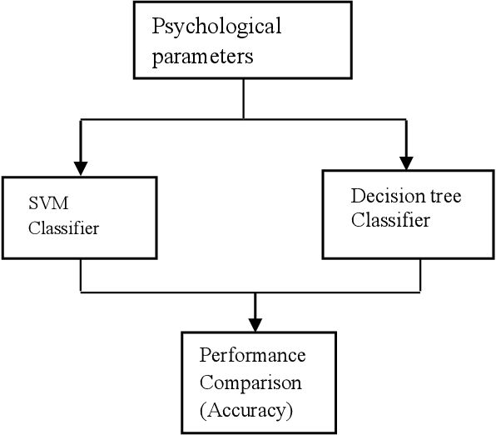

Prototype:
python 3.7.0 or 3.7.4
OpenCV-python==4.5.1.48
koras==2.3.1
TensorFlow==1.14.0
protosun==3.16.0
h5py==2.10.0
sclera-extensions==0.0.2
sickie-learn==0.22.2. post1
NumPy
Pandas
Models and Diagrams:
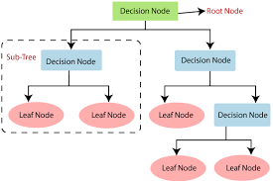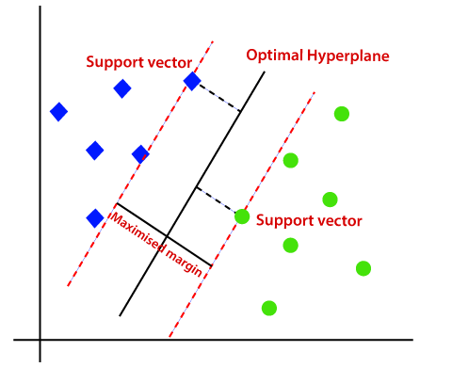

NON-FUNCTIONAL REQUIREMENT:
Usability: Usability is a quality attribute that assesses how easy user interfaces are to use. The word "usability" also refers to methods for improving ease-of-use during the design process.(how it was handle entire project easy)
Security: the quality or state of being secure: such as. a : freedom from danger : safety. b : freedom from fear or anxiety. c : freedom from the prospect of being laid off job security.

Readability: Readability is the ease with which a reader can understand a written text.
Performance: the execution of an action. : something accomplished : deed, feat. : the fulfillment of a claim, promise, or request : implementation. 3. : the action of representing a character in a play.
Availability: the quality or state of being available trying to improve the availability of affordable housing. 2 : an available person or thing.
Scalability: Scalability is the measure of a system's ability to increase or decrease in performance and cost in response to changes in application and system processing demands.

3.3. PROCESS MODEL USED WITH JUSTIFICATION
SDLC (Umbrella Model):
Umbrella Activity
Umbrella Activity
Umbrella Activity
- Feasibility Study
- TEAM FORMATION
- Project Specification PREPARATION

Business Requirement Documentation
ANALYSIS & DESIGN
CODE
UNIT TEST
DOCUMENT CONTROL

ASSESSMENT

TRAINING
INTEGRATION & SYSTEM TESTING

DELIVERY/INSTALLATION
ACCEPTANCE TEST
Requirements Gathering
SDLC is nothing but Software Development Life Cycle. It is a standard which is used by software industry to develop good software.
Stages in SDLC:
- Requirement Gathering
- Analysis
- Designing
- Coding
- Testing
- Maintenance
Requirements Gathering stage:
The requirements gathering process takes as its input the goals identified in the high-level requirements section of the project plan. Each goal will be refined into a set of one or more requirements. These requirements define the major functions of the intended application, define operational data areas and reference data areas, and define the initial data entities. Major functions include critical processes to be managed, as well as mission critical inputs, outputs and reports. A user class hierarchy is developed and associated with these major functions, data areas, and data entities. Each of these definitions is termed a Requirement. Requirements are identified by unique requirement identifiers and, at minimum, contain a requirement title and textual description.
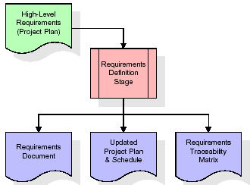
These requirements are fully described in the primary deliverables for this stage: the Requirements Document and the Requirements Traceability Matrix (RTM). The requirements document contains complete descriptions of each requirement, including diagrams and references to external documents as necessary. Note that detailed listings of database tables and fields are not included in the requirements document.
The title of each requirement is also placed into the first version of the RTM, along with the title of each goal from the project plan. The purpose of the RTM is to show that the product components developed during each stage of the software development lifecycle are formally connected to the components developed in prior stages.
In the requirements stage, the RTM consists of a list of high-level requirements, or goals, by title, with a listing of associated requirements for each goal, listed by requirement title. In this hierarchical listing, the RTM shows that each requirement developed during this stage is formally linked to a specific product goal. In this format, each requirement can be traced to a specific product goal, hence the term requirements traceability.
The outputs of the requirements definition stage include the requirements document, the RTM, and an updated project plan.
- Feasibility study is all about identification of problems in a project.
- No. of staff required to handle a project is represented as Team Formation, in this case only modules are individual tasks will be assigned to employees who are working for that project.
- Project Specifications are all about representing of various possible inputs submitting to the server and corresponding outputs along with reports maintained by administrator.
Analysis Stage:
The planning stage establishes a bird's eye view of the intended software product, and uses this to establish the basic project structure, evaluate feasibility and risks associated with the project, and describe appropriate management and technical approaches.
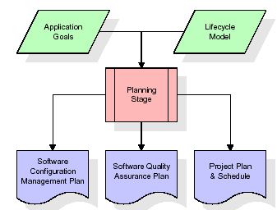
The most critical section of the project plan is a listing of high-level product requirements, also referred to as goals. All of the software product requirements to be developed during the requirements definition stage flow from one or more of these goals. The minimum information for each goal consists of a title and textual description, although additional information and references to external documents may be included. The outputs of the project planning stage are the configuration management plan, the quality assurance plan, and the project plan and schedule, with a detailed listing of scheduled activities for the upcoming Requirements stage, and high level estimates of effort for the out stages.
Designing Stage:
The design stage takes as its initial input the requirements identified in the approved requirements document. For each requirement, a set of one or more design elements will be produced as a result of interviews, workshops, and/or prototype efforts. Design elements describe the desired software features in detail, and generally include functional hierarchy diagrams, screen layout diagrams, tables of business rules, business process diagrams, pseudo code, and a complete entity-relationship diagram with a full data dictionary. These design elements are intended to describe the software in sufficient detail that skilled programmers may develop the software with minimal additional input.

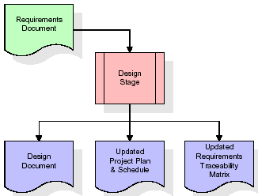
When the design document is finalized and accepted, the RTM is updated to show that each design element is formally associated with a specific requirement. The outputs of the design stage are the design document, an updated RTM, and an updated project plan.
Development (Coding) Stage:
The development stage takes as its primary input the design elements described in the approved design document. For each design element, a set of one or more software artifacts will be produced. Software artifacts include but are not limited to menus, dialogs, and data management forms, data reporting formats, and specialized procedures and functions. Appropriate test cases will be developed for each set of functionally related software artifacts, and an online help system will be developed to guide users in their interactions with the software.
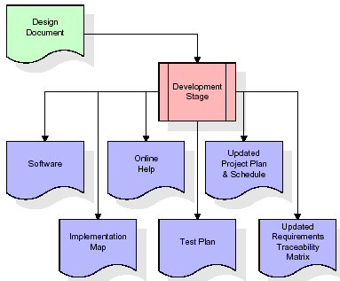

The RTM will be updated to show that each developed artifact is linked to a specific design element, and that each developed artifact has one or more corresponding test case items. At this point, the RTM is in its final configuration. The outputs of the development stage include a fully functional set of software that satisfies the requirements and design elements previously documented, an online help system that describes the operation of the software, an implementation map that identifies the primary code entry points for all major system functions, a test plan that describes the test cases to be used to validate the correctness and completeness of the software, an updated RTM, and an updated project plan.
Integration & Test Stage:
During the integration and test stage, the software artifacts, online help, and test data are migrated from the development environment to a separate test environment. At this point, all test cases are run to verify the correctness and completeness of the software. Successful execution of the test suite confirms a robust and complete migration capability. During this stage, reference data is finalized for production use and production users are identified and linked to their appropriate roles. The final reference data (or links to reference data source files) and production user list are compiled into the Production Initiation Plan.
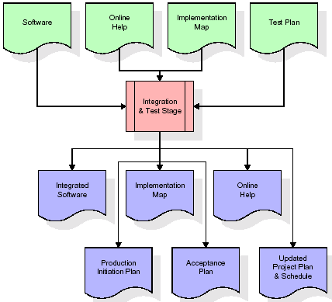
The outputs of the integration and test stage include an integrated set of software, an online help system, an implementation map, a production initiation plan that describes reference data and production users, an acceptance plan which contains the final suite of test cases, and an updated project plan.
- Installation & Acceptance Test:
During the installation and acceptance stage, the software artifacts, online help, and initial production data are loa ded onto the production server. At this point, all test cases are run to verify the correctness and completeness of the software. Successful execution of the test suite is a prerequisite to acceptance of the software by the customer.
After customer personnel have verified that the initial production data load is correct and the test suite has been executed with satisfactory results, the customer formally accepts the delivery of the software.
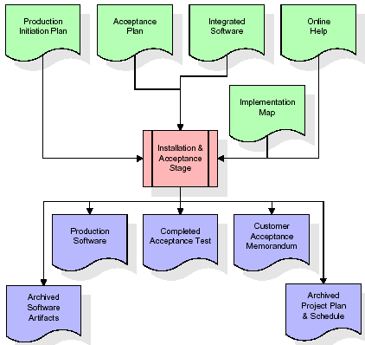
The primary outputs of the installation and acceptance stage include a production application, a completed acceptance test suite, and a memorandum of customer acceptance of the software. Finally, the PDR enters the last of the actual labor data into the project schedule and locks the project as a permanent project record. At this point the PDR "locks" the project by archiving all software items, the implementation map, the source code, and the documentation for future reference.
Maintenance:
Outer rectangle represents maintenance of a project, Maintenance team will start with requirement study, understanding of documentation later employees will be assigned work and they will undergo training on that particular assigned category. For this life cycle there is no end, it will be continued so on like an umbrella (no ending point to umbrella sticks).
3.4. Software Requirement Specification
3.4.1. Overall Description
A Software Requirements Specification (SRS) – a requirements specification for a software system is a complete description of the behavior of a system to be developed. It includes a set of use cases that describe all the interactions the users will have with the software. In addition to use cases, the SRS also contains non-functional requirements. Nonfunctional requirements are requirements which impose constraints on the design or implementation (such as performance engineering requirements, quality standards, or design constraints).
System requirements specification: A structured collection of information that embodies the requirements of a system. A business analyst, sometimes titled system analyst, is responsible for analyzing the business needs of their clients and stakeholders to help identify business problems and propose solutions. Within the systems development lifecycle domain, the BA typically performs a liaison function between the business side of an enterprise and the information technology department or external service providers. Projects are subject to three sorts of requirements:
- Business requirements describe in business terms what must be delivered or accomplished to provide value.
- Product requirements describe properties of a system or product (which could be one of several ways to accomplish a set of business requirements.)
- Process requirements describe activities performed by the developing organization. For instance, process requirements could specify .Preliminary investigation examine project feasibility, the likelihood the system will be useful to the organization. The main objective of the feasibility study is to test the Technical, Operational and Economical feasibility for adding new modules and debugging old running system. All system is feasible if they are unlimited resources and infinite time. There are aspects in the feasibility study portion of the preliminary investigation:
- ECONOMIC FEASIBILITY
A system can be developed technically and that will be used if installed must still be a good investment for the organization. In the economical feasibility, the development cost in creating the system is evaluated against the ultimate benefit derived from the new systems. Financial benefits must equal or exceed the costs. The system is economically feasible. It does not require any addition hardware or software. Since the interface for this system is developed using the existing resources and technologies available at NIC, There is nominal expenditure and economical feasibility for certain.
- Operational Feasibility
Proposed projects are beneficial only if they can be turned out into information system. That will meet the organization’s operating requirements. Operational feasibility aspects of the project are to be taken as an important part of the project implementation. This system is targeted to be in accordance with the above-mentioned issues. Beforehand, the management issues and user requirements have been taken into consideration. So there is no question of resistance from the users that can undermine the possible application benefits. The well-planned design would ensure the optimal utilization of the computer resources and would help in the improvement of performance status.
- TECHNICAL FEASIBILITY
Earlier no system existed to cater to the needs of ‘Secure Infrastructure Implementation System’. The current system developed is technically feasible. It is a web based user interface for audit workflow at NIC-CSD. Thus it provides an easy access to .the users. The database’s purpose is to create, establish and maintain a workflow among various entities in order to facilitate all concerned users in their various capacities or roles. Permission to the users would be granted based on the roles specified. Therefore, it provides the technical guarantee of accuracy, reliability and security.
3.4.2. External Interface Requirements
User Interface
The user interface of this system is a user friendly python Graphical User Interface.
Hardware Interfaces
The interaction between the user and the console is achieved through python capabilities.
Software Interfaces
The required software is python.
SYSTEM REQUIREMENTS:
HARDWARE REQUIREMENTS:

Processor - intel i3 or above
- Speed - 1.1 Ghz
- RAM - 4 GB or above
- Hard Disk - 500 GB or above
- Key Board - Standard Windows Keyboard
- Mouse - Two or Three Button Mouse
- Monitor - SVGA
SOFTWARE REQUIREMENTS:
Operating System - Windows10 or above
Programming Language - Python
4. SYSTEM DESIGN
UML Diagram:
The Unified Modeling Language allows the software engineer to express an analysis model using the modeling notation that is governed by a set of syntactic semantic and pragmatic rules.
A UML system is represented using five different views that describe the system from distinctly different perspective. Each view is defined by a set of diagram, which is as follows.
  - User Model View
    - This view represents the system from the users perspective.
    - The analysis representation describes a usage scenario from the end-users perspective.
  - Structural Model view
    - In this model the data and functionality are arrived from inside the system.
    - This model view models the static structures.
- Behavioral Model View
It represents the dynamic of behavioral as parts of the system, depicting the interactions of collection between various structural elements described in the user model and structural model view.
- Implementation Model View
In this the structural and behavioral as parts of the system are represented as they are to be built.
- Environmental Model View
In this the structural and behavioral aspects of the environment in which the system is to be implemented are represented.

Class Diagram:
The class diagram is the main building block of object oriented modeling. It is used both for general conceptual modeling of the systematic of the application, and for detailed modeling translating the models into programming code. Class diagrams can also be used for data modeling. The classes in a class diagram represent both the main objects, interactions in the application and the classes to be programmed. In the diagram, classes are represented with boxes which contain three parts:
- The upper part holds the name of the class
- The middle part contains the attributes of the class
- The bottom part gives the methods or operations the class can take or undertake

Use case Diagram:
A use case diagram at its simplest is a representation of a user's interaction with the system and depicting the specifications of a use case. A use case diagram can portray the different types of users of a system and the various ways that they interact with the system. This type of diagram is typically used in conjunction with the textual use case and will often be accompanied by other types of diagrams as well.

Sequence diagram:
A sequence diagram is a kind of interaction diagram that shows how processes operate with one another and in what order. It is a construct of a Message Sequence Chart. A sequence diagram shows object interactions arranged in time sequence. It depicts the objects and classes involved in the scenario and the sequence of messages exchanged between the objects needed to carry out the functionality of the scenario. Sequence diagrams are typically associated with use case realizations in the Logical View of the system under development. Sequence diagrams are sometimes called event diagrams, event scenarios, and timing diagrams.

Collaboration diagram:
A collaboration diagram describes interactions among objects in terms of sequenced messages. Collaboration diagrams represent a combination of information taken from class, sequence, and use case diagrams describing both the static structure and dynamic behavior of a system.

Component Diagram:
In the Unified Modeling Language, a component diagram depicts how components are wired together to form larger components and or software systems. They are used to illustrate the structure of arbitrarily complex systems.
Components are wired together by using an assembly connector to connect the required interface of one component with the provided interface of another component. This illustrates the service consumer - service provider relationship between the two components.

Deployment Diagram:
A deployment diagram in the Unified Modeling Language models the physical deployment of artifacts on nodes. To describe a web site, for example, a deployment diagram would show what hardware components ("nodes") exist (e.g., a web server, an application server, and a database server), what software components ("artifacts") run on each node (e.g., web application, database), and how the different pieces are connected (e.g. JDBC, REST, RMI).
The nodes appear as boxes, and the artifacts allocated to each node appear as rectangles within the boxes. Nodes may have sub nodes, which appear as nested boxes. A single node in a deployment diagram may conceptually represent multiple physical nodes, such as a cluster of database servers.

Activity Diagram:
Activity diagram is another important diagram in UML to describe dynamic aspects of the system. It is basically a flow chart to represent the flow form one activity to another activity. The activity can be described as an operation of the system. So the control flow is drawn from one operation to another. This flow can be sequential, branched or concurrent
Activity Diagram:

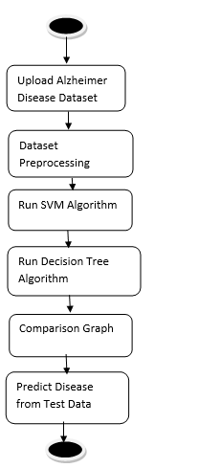
Data Flow Diagram:
Data flow diagrams illustrate how data is processed by a system in terms of inputs and outputs. Data flow diagrams can be used to provide a clear representation of any business function. The technique starts with an overall picture of the business and continues by analyzing each of the functional areas of interest. This analysis can be carried out in precisely the level of detail required. The technique exploits a method called top-down expansion to conduct the analysis in a targeted way.
As the name suggests, Data Flow Diagram (DFD) is an illustration that explicates the passage of information in a process. A DFD can be easily drawn using simple symbols. Additionally, complicated processes can be easily automated by creating DFDs using easy-to-use, free downloadable diagramming tools. A DFD is a model for constructing and analyzing information processes. DFD illustrates the flow of information in a process depending upon the inputs and outputs. A DFD can also be referred to as a Process Model. A DFD demonstrates business or technical process with the support of the outside data saved, plus the data flowing from the process to another and the end results.

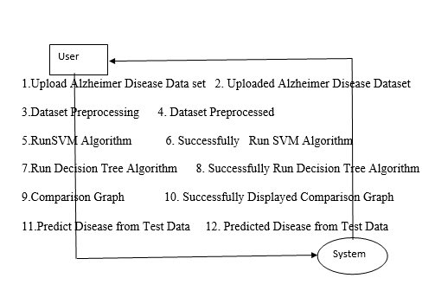

5. IMPLEMETATION
5.1 Python
Python is a general-purpose language. It has wide range of applications from Web development (like: Django and Bottle), scientific and mathematical computing (Orange, SymPy, NumPy) to desktop graphical user Interfaces (Pygame, Panda3D). The syntax of the language is clean and length of the code is relatively short. It's fun to work in Python because it allows you to think about the problem rather than focusing on the syntax.
History of Python:
Python is a fairly old language created by Guido Van Rossum. The design began in the late 1980s and was first released in February 1991.
Why Python was created?
In late 1980s, Guido Van Rossum was working on the Amoeba distributed operating system group. He wanted to use an interpreted language like ABC (ABC has simple easy-to-understand syntax) that could access the Amoeba system calls. So, he decided to create a language that was extensible. This led to design of a new language which was later named Python.
Why the name Python?
No. It wasn't named after a dangerous snake. Rossum was fan of a comedy series from late seventies. The name "Python" was adopted from the same series "Monty Python's Flying Circus".

Features of Python:
A simple language which is easier to learn
Python has a very simple and elegant syntax. It's much easier to read and write Python programs compared to other languages like: C++, Java, C#. Python makes programming fun and allows you to focus on the solution rather than syntax.
If you are a newbie, it's a great choice to start your journey with Python.
Free and open-source
You can freely use and distribute Python, even for commercial use. Not only can you use and distribute software’s written in it, you can even make changes to the Python's source code.
Python has a large community constantly improving it in each iteration.
Portability
You can move Python programs from one platform to another, and run it without any changes.
It runs seamlessly on almost all platforms including Windows, Mac OS X and Linux.
Extensible and Embeddable
Suppose an application requires high performance. You can easily combine pieces of C/C++ or other languages with Python code.
This will give your application high performance as well as scripting capabilities which other languages may not provide out of the box.
A high-level, interpreted language
Unlike C/C++, you don't have to worry about daunting tasks like memory management, garbage collection and so on.
Likewise, when you run Python code, it automatically converts your code to the language your computer understands. You don't need to worry about any lower-level operations.
Large standard libraries to solve common tasks
Python has a number of standard libraries which makes life of a programmer much easier since you don't have to write all the code yourself. For example: Need to connect MySQL database on a Web server? You can use MySQLdb library using import MySQLdb .
Standard libraries in Python are well tested and used by hundreds of people. So you can be sure that it won't break your application.
Object-oriented
Everything in Python is an object. Object oriented programming (OOP) helps you solve a complex problem intuitively.
With OOP, you are able to divide these complex problems into smaller sets by creating objects.
Applications of Python:
1. Simple Elegant Syntax
Programming in Python is fun. It's easier to understand and write Python code. Why? The syntax feels natural. Take this source code for an example:
a = 2
b = 3
sum = a + b
print(sum)
2. Not overly strict
You don't need to define the type of a variable in Python. Also, it's not necessary to add semicolon at the end of the statement.
Python enforces you to follow good practices (like proper indentation). These small things can make learning much easier for beginners.
3. Expressiveness of the language
Python allows you to write programs having greater functionality with fewer lines of code. Here's a link to the source code of Tic-tac-toe game with a graphical interface and a smart computer opponent in less than 500 lines of code. This is just an example. You will be amazed how much you can do with Python once you learn the basics.
4. Great Community and Support
Python has a large supporting community. There are numerous active forums online which can be handy if you are stuck.
5.2 Sample Code:
import pandas as pd
from tkinter import messagebox
from tkinter import *
from tkinter import simpledialog
import tkinter
from tkinter import filedialog
import matplotlib.pyplot as plt
import numpy as np
from tkinter.filedialog import askopenfilename
import os
from sklearn.model_selection import train_test_split

from sklearn.preprocessing import LabelEncoder
from sklearn.metrics import accuracy_score
from sklearn.tree import DecisionTreeClassifier
from sklearn.metrics import precision_score
from sklearn.metrics import recall_score
from sklearn.metrics import f1_score
from sklearn import svm

main = tkinter.Tk()
main.title("Alzheimer Disease Prediction using Machine Learning Algorithms")
main.geometry("1300x1200")

global filename, dataset
global X, Y
global error
global le1, le2, le3
global X_train, X_test, y_train, y_test, classifier

accuracy = []
precision = []
recall = []
fscore = []

def upload ():
global filename, dataset
filename = filedialog.askopenfilename(initialdir="Dataset")
pathlabel.config(text=filename)
text.delete('1.0', END)
text.insert(END,filename+" loaded\n\n")
dataset = pd.read_csv(filename)
text.insert(END,str(dataset.head()))
label = dataset.groupby('Group').size()
label.plot(kind="bar")
plt.show()

def processDataset():
global dataset
global X, Y
global le1, le2, le3
global X_train, X_test, y_train, y_test
text.delete('1.0', END)
le1 = LabelEncoder()
le2 = LabelEncoder()
le3 = LabelEncoder()

dataset.fillna(0, inplace = True)
dataset.drop(['Subject ID'], axis = 1,inplace=True)
dataset.drop(['MRI ID'], axis = 1,inplace=True)
dataset['Group'] = pd.Series(le1.fit_transform(dataset['Group'].astype(str)))
dataset['M/F'] = pd.Series(le2.fit_transform(dataset['M/F'].astype(str)))
dataset['Hand'] = pd.Series(le3.fit_transform(dataset['Hand'].astype(str)))
text.insert(END,str(dataset)+"\n\n")

dataset = dataset.values
X = dataset[:,1:dataset.shape[1]]
Y = dataset[:,0]

X_train, X_test, y_train, y_test = train_test_split(X, Y, test_size=0.2)
text.insert(END,"Dataset train & test split details\n\n")
text.insert(END,"Total records found in dataset : "+str(X.shape[0])+"\n")
text.insert(END,"80% dataset used for training : "+str(X_train.shape[0])+"\n")
text.insert(END,"20% dataset used for testing : "+str(X_test.shape[0])+"\n")

def calculateMetrics(algorithm, predict, y_test):
a = accuracy_score(y_test,predict)*100
p = precision_score(y_test, predict,average='macro') * 100
r = recall_score(y_test, predict,average='macro') * 100
f = f1_score(y_test, predict,average='macro') * 100
accuracy.append(a)
precision.append(p)
recall.append(r)
fscore.append(f)
text.insert(END,algorithm+" Accuracy : "+str(a)+"\n")
text.insert(END,algorithm+" Precision : "+str(p)+"\n")
text.insert(END,algorithm+" Recall : "+str(r)+"\n")
text.insert(END,algorithm+" FScore : "+str(f)+"\n\n")

def runSVM():
text.delete('1.0', END)
global X,Y, X_train, X_test, y_train, y_test, classifier
global accuracy, precision,recall, fscore
accuracy.clear()
precision.clear()
recall.clear()
fscore.clear()

svm_cls = svm.SVC(C=2.0,gamma='scale',kernel = 'rbf', random_state = 2)
svm_cls.fit(X, Y)
predict = svm_cls.predict(X_test)
calculateMetrics("SVM", predict, y_test)

def runDecisionTree():
global X,Y, X_train, X_test, y_train, y_test, classifier
global accuracy, precision,recall, fscore

dt = DecisionTreeClassifier()
dt.fit(X_train, y_train)
predict = dt.predict(X_test)
calculateMetrics("Decision Tree", predict, y_test)
classifier = dt

def predict():
global classifier
global le1, le2, le3
text.delete('1.0', END)
filename = filedialog.askopenfilename(initialdir = "Dataset")
test = pd.read_csv(filename)
test.fillna(0, inplace = True)
test.drop(['Subject ID'], axis = 1,inplace=True)
test.drop(['MRI ID'], axis = 1,inplace=True)
test['M/F'] = pd.Series(le2.transform(test['M/F'].astype(str)))
test['Hand'] = pd.Series(le3.transform(test['Hand'].astype(str)))
test = test.values
predict = classifier.predict(test)
print(predict)
for i in range(len(predict)):
if predict[i] == 0:
text.insert(END,"Patient Test Data = "+str(test[i])+" ====> PREDICTED AS CURED\n\n")
if predict[i] == 1:
text.insert(END,"Patient Test Data = "+str(test[i])+" ====> PREDICTED AS Presence of Alzheimer Disease\n\n")
if predict[i] == 2:
text.insert(END,"Patient Test Data = "+str(test[i])+" ====> PREDICTED AS NORMAL\n\n")

def graph():
df = pd.DataFrame([['SVM','Precision',precision[0]],['SVM','Recall',recall[0]],['SVM','F1 Score',fscore[0]],['SVM','Accuracy',accuracy[0]],
['Decision Tree','Precision',precision[1]],['Decision Tree','Recall',recall[1]],['Decision Tree','F1 Score',fscore[1]],['Decision Tree','Accuracy',accuracy[1]],
],columns=['Algorithms','Parameters','Value'])
df.pivot("Algorithms", "Parameters", "Value").plot(kind='bar')
plt.show()

font = ('times', 14, 'bold')
title = Label(main, text='Alzheimer Disease Prediction using Machine Learning Algorithms')
title.config(bg='yellow3', fg='white')
title.config(font=font)
title.config(height=3, width=120)
title.place(x=0,y=5)

font1 = ('times', 13, 'bold')
uploadButton = Button(main, text="Upload Alzheimer Disease Dataset", command=upload)
uploadButton.place(x=50,y=100)
uploadButton.config(font=font1)

pathlabel = Label(main)
pathlabel.config(bg='brown', fg='white')
pathlabel.config(font=font1)
pathlabel.place(x=470,y=100)

processButton = Button(main, text="Dataset Preprocessing", command=processDataset)
processButton.place(x=50,y=150)
processButton.config(font=font1)

svmButton = Button(main, text="Run SVM Algorithm", command=runSVM)
svmButton.place(x=280,y=150)
svmButton.config(font=font1)

dtButton = Button(main, text="Run Decision Tree Algorithm", command=runDecisionTree)
dtButton.place(x=470,y=150)
dtButton.config(font=font1)

graphbutton = Button(main, text="Comparison Graph", command=graph)
graphbutton.place(x=50,y=200)
graphbutton.config(font=font1)

predictButton = Button(main, text="Predict Disease from Test Data", command=predict)
predictButton.place(x=280,y=200)
predictButton.config(font=font1)

font1 = ('times', 12, 'bold')
text=Text(main,height=22,width=150)
scroll=Scrollbar(text)
text.configure(yscrollcommand=scroll.set)
text.place(x=10,y=250)
text.config(font=font1)

main.config(bg='burlywood2')
main.mainloop()

6. TESTING
Implementation and Testing:
Implementation is one of the most important tasks in project is the phase in which one has to be cautions because all the efforts undertaken during the project will be very interactive. Implementation is the most crucial stage in achieving successful system and giving the users confidence that the new system is workable and effective. Each program is tested individually at the time of development using the sample data and has verified that these programs link together in the way specified in the program specification. The computer system and its environment are tested to the satisfaction of the user.

Implementation

The implementation phase is less creative than system design. It is primarily concerned with user training, and file conversion. The system may be requiring extensive user training. The initial parameters of the system should be modifies as a result of a programming. A simple operating procedure is provided so that the user can understand the different functions clearly and quickly. The different reports can be obtained either on the inkjet or dot matrix printer, which is available at the disposal of the user. The proposed system is very easy to implement. In general implementation is used to mean the process of converting a new or revised system design into an operational one.

Testing
Testing is the process where the test data is prepared and is used for testing the modules individually and later the validation given for the fields. Then the system testing takes place which makes sure that all components of the system property functions as a unit. The test data should be chosen such that it passed through all possible condition. Actually testing is the state of implementation which aimed at ensuring that the system works accurately and efficiently before the actual operation commence. The following is the description of the testing strategies, which were carried out during the testing period.

System Testing
Testing has become an integral part of any system or project especially in the field of information technology. The importance of testing is a method of justifying, if one is ready to move further, be it to be check if one is capable to with stand the rigors of a particular situation cannot be underplayed and that is why testing before development is so critical. When the software is developed before it is given to user to use the software must be tested whether it is solving the purpose for which it is developed. This testing involves various types through which one can ensure the software is reliable. The program was tested logically and pattern of execution of the program for a set of data are repeated. Thus the code was exhaustively checked for all possible correct data and the outcomes were also checked.

Module Testing
To locate errors, each module is tested individually. This enables us to detect error and correct it without affecting any other modules. Whenever the program is not satisfying the required function, it must be corrected to get the required result. Thus all the modules are individually tested from bottom up starting with the smallest and lowest modules and proceeding to the next level. Each module in the system is tested separately. For example the job classification module is tested separately. This module is tested with different job and its approximate execution time and the result of the test is compared with the results that are prepared manually. The comparison shows that the results proposed system works efficiently than the existing system. Each module in the system is tested separately. In this system the resource classification and job scheduling modules are tested separately and their corresponding results are obtained which reduces the process waiting time.
Integration Testing
After the module testing, the integration testing is applied. When linking the modules there may be chance for errors to occur, these errors are corrected by using this testing. In this system all modules are connected and tested. The testing results are very correct. Thus the mapping of jobs with resources is done correctly by the system.
Acceptance Testing
When that user fined no major problems with its accuracy, the system passers through a final acceptance test. This test confirms that the system needs the original goals, objectives and requirements established during analysis without actual execution which elimination wastage of time and money acceptance tests on the shoulders of users and management, it is finally acceptable and ready for the operation.

Test Case Id | Test Case Name | Test Case Desc. | Test Steps |  |  | Test Case Status | Test Priority
 |  |  | Step | Expected | Actual
01 | Upload Alzheimer Disease Dataset | Verify the Alzheimer  Disease Dataset Uploaded or not | If the dataset may not Uploaded | User cannot Further operations | User can Further operations | High | High
02 | Dataset Preprocessing | Verify the Dataset Preprocessed  or not | If the dataset is may not be preprocessed | User cannot Further operations | User can Further operations | High | High
03 | Run SVM Algorithm | Verify SVM  Algorithm is successfully run or not | If SVM algorithm is may not be run | User cannot Further operations | User can Further operations | High | High
04 | Run Decision Tree Algorithm | Verify Decision Tree  Algorithm is successfully run or not | If Decision Tree algorithm is may not be run | User cannot Further operations | User can Further operations | High | High
05 | Comparison Graph | Verify Graph is done or not | If comparison Graph is may not be Displayed | User cannot Further operations | User can Further operations | High | High
06 | Predict Disease from Test Data | Verify Disease from Test predicted or not | If Disease from test may not be predicted | User cannot Further operations | User can Further operations | High | High

7. SCREENSHOTS
Alzheimer Disease Prediction using Machine Learning Algorithms
Alzheimer Disease is one of the incurable and dangerous disease and its timely prediction can help in saving patients life. So author of this paper using machine learning algorithms such as SVM and decision tree to predict cured, non-Alzheimer and Alzheimer patients. To trained this algorithms author using dataset which contains patient AGE, number of visits to hospital and many other parameters. After training model we can apply test data on this model to predict patient condition as Normal or Alzheimer.
Below screen showing dataset details used in this project
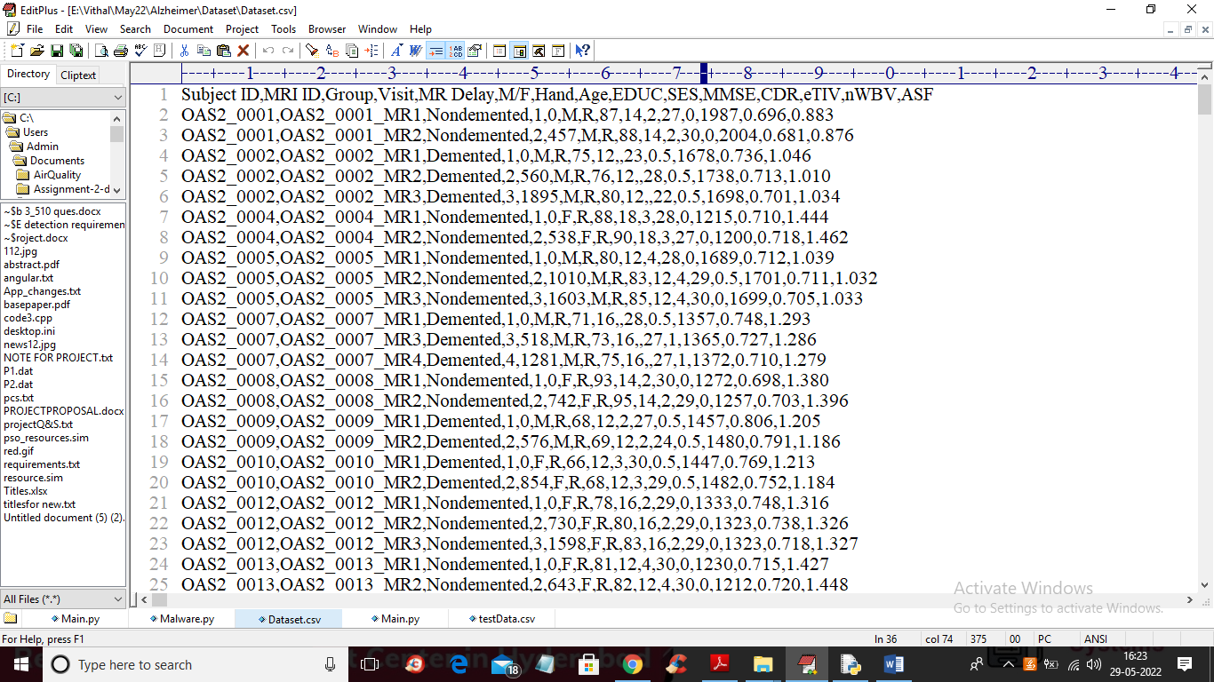
In above screen first row contains dataset column names and remaining rows contains dataset values and by using above dataset we are training SVM and Decision tree algorithms and then comparing their performance in terms of accuracy.
To run project double click on ‘run.bat’ file to get below screen
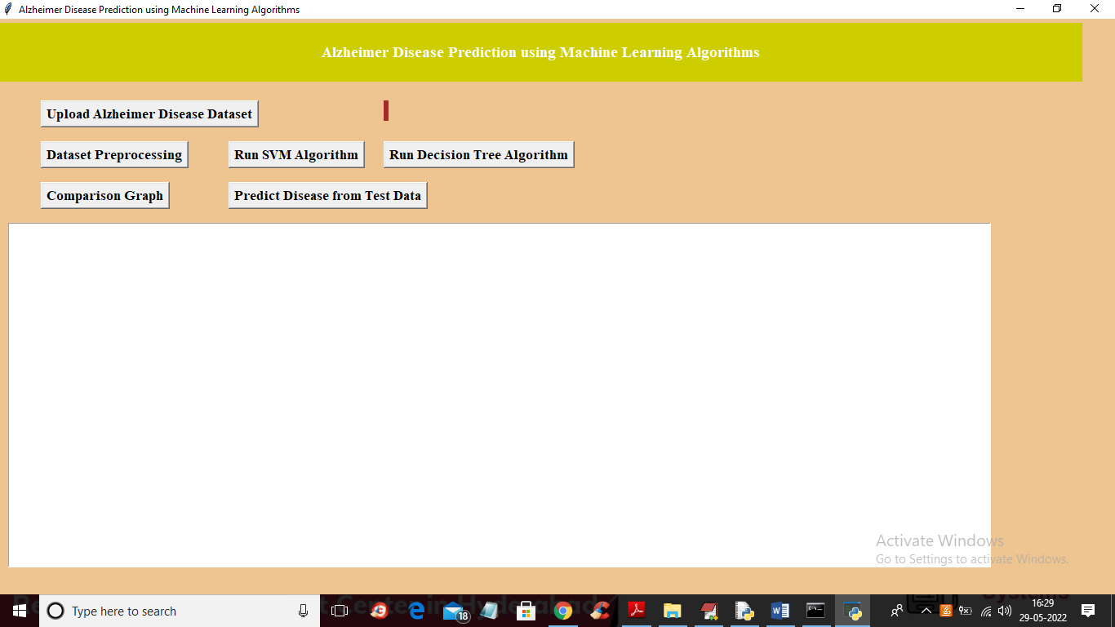
In above screen click on ‘Upload Alzheimer Disease Dataset’ button to upload dataset and to get below screen
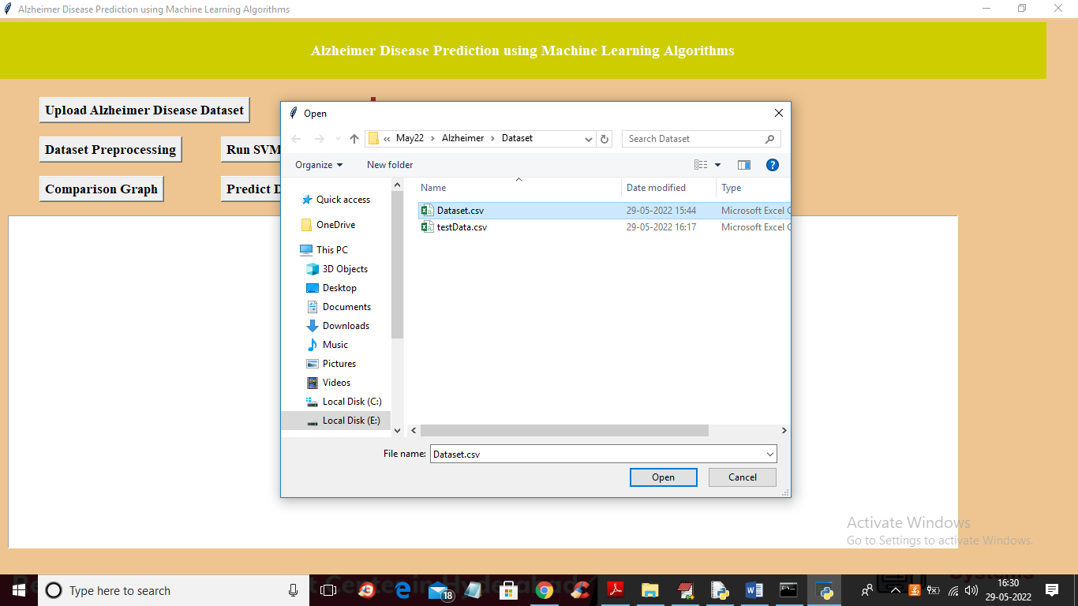
In above screen selecting and uploading ‘Dataset.csv’ file and then click on ‘Open’ button to load dataset and get below output
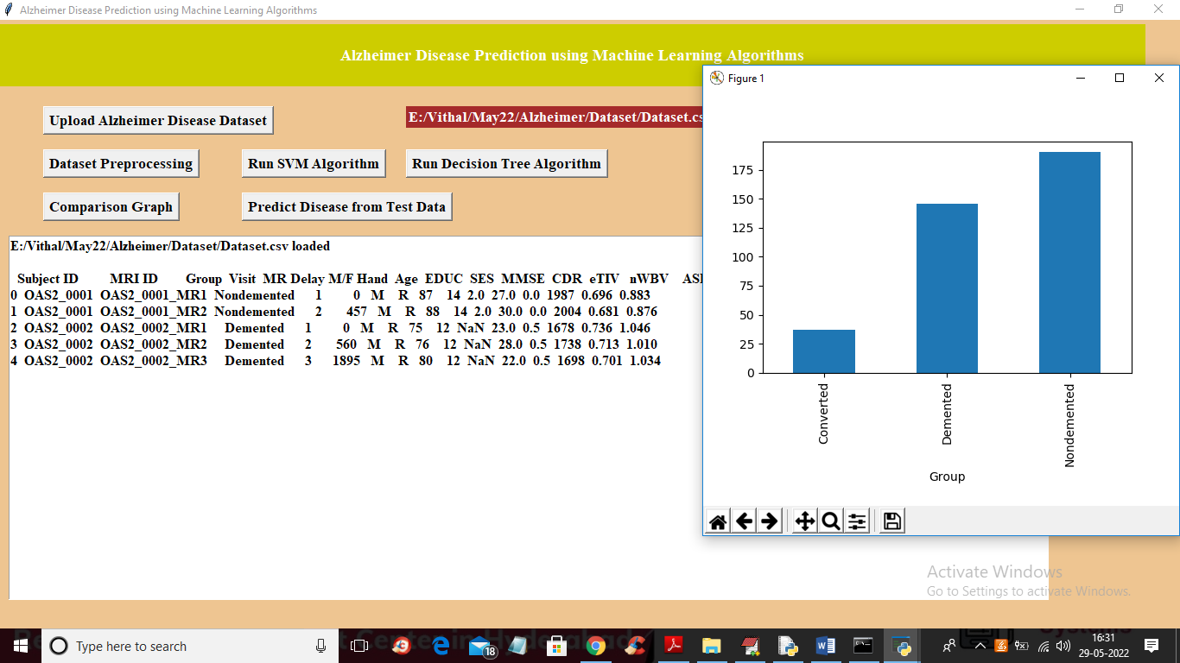
In above screen dataset loaded and we can see dataset contains some NAN or missing values and contains nom-numeric data also so we need to preprocess dataset to remove such values and in above graph x-axis contains LABELS such as ‘Converted’ mean cured and Demented means presence of Alzheimer and Nondemented means normal and y-axis represents number of records found in that category in dataset. Now close above graph and then click on ‘Dataset Preprocessing’ button to process dataset and get below output
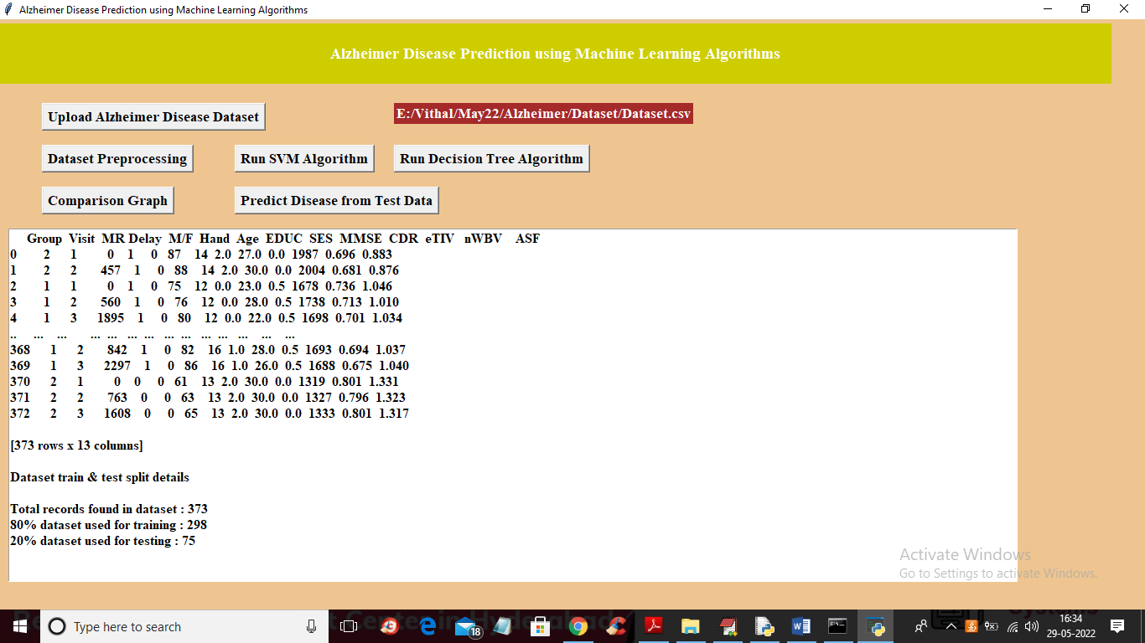
In above screen we can see all dataset values are converted to numeric and we can see dataset contains 373 records and 298 (80%) are using for training and 75 (20%) records are used for testing algorithm prediction accuracy. Now train and test data is ready and now click on ‘Run SVM Algorithm’ button to train SVM and get below output
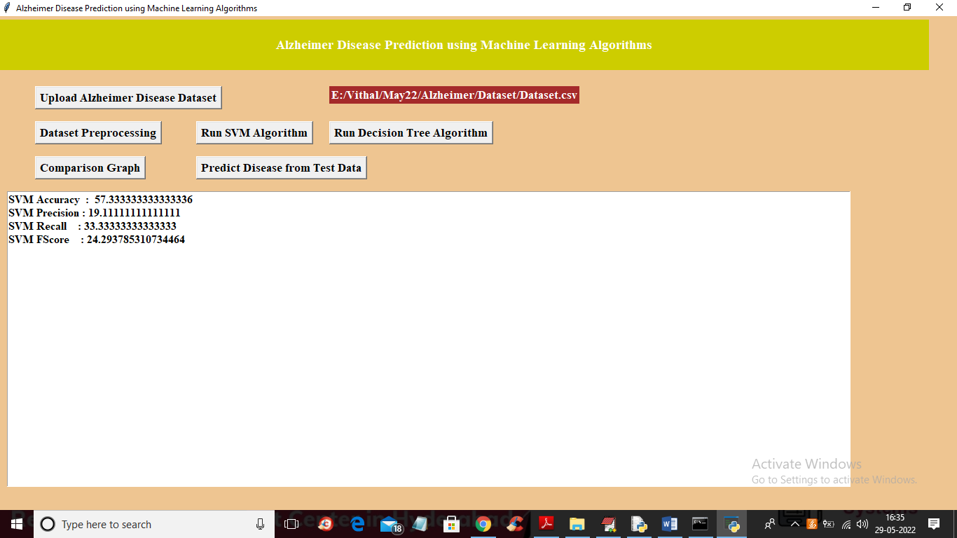
In above screen with SVM we got 57% accuracy and now click on ‘Run Decision Tree Algorithm’ button to train Decision tree and get below output
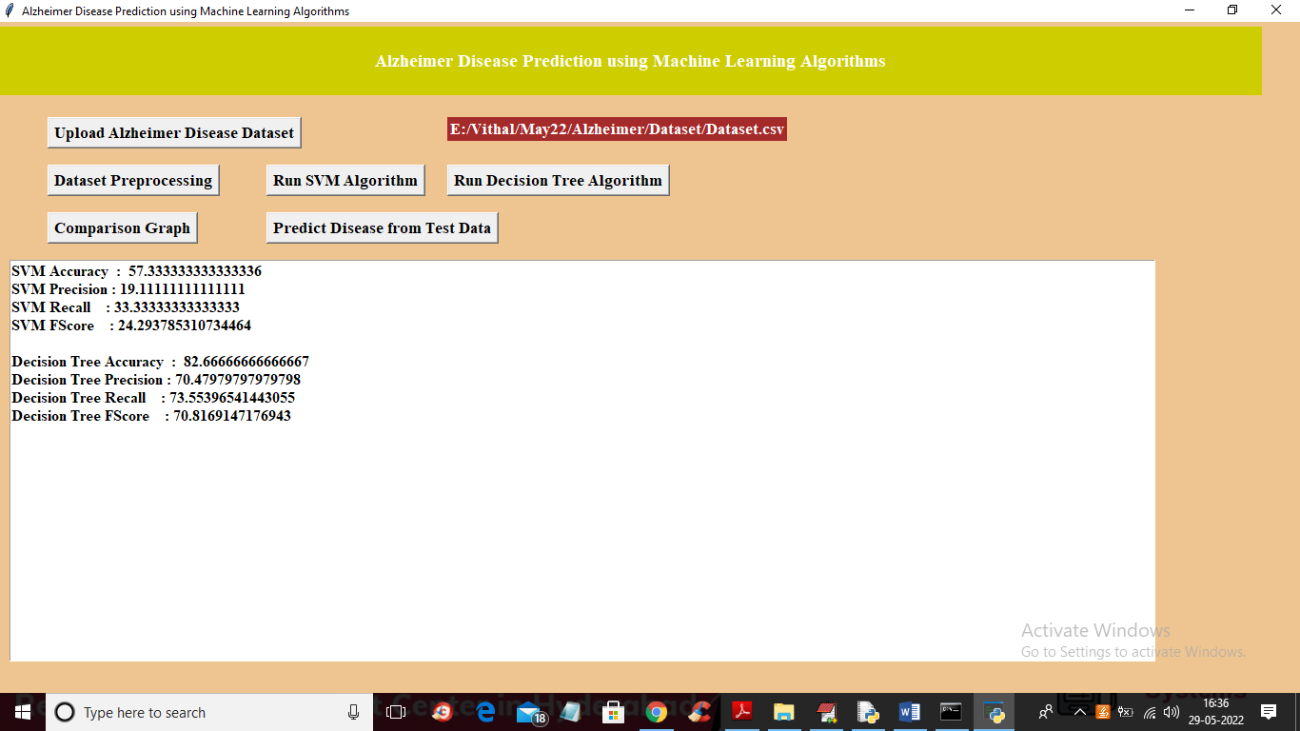
In above screen with decision tree we got 82% accuracy and now click on ‘Comparison Graph’ button to get below output
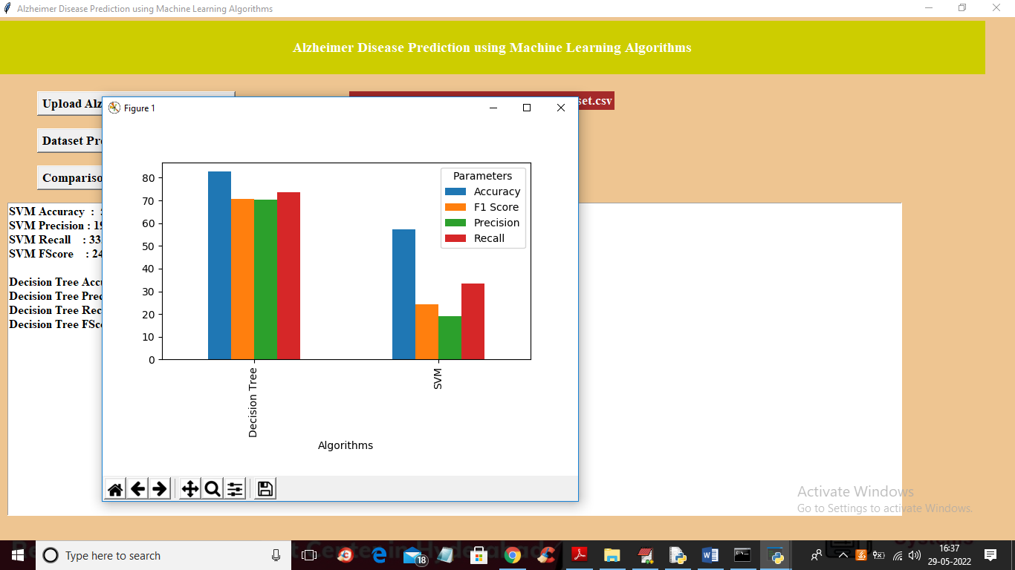
In above graph x-axis represents algorithm names with different bar in different colour metrics such as accuracy, precision, recall and FSCORE and y-axis represents values. In above graph we can see Decision Tree got high performance and now close above graph and then click on ‘Predict Disease from Test Data’ button to upload test and get prediction output
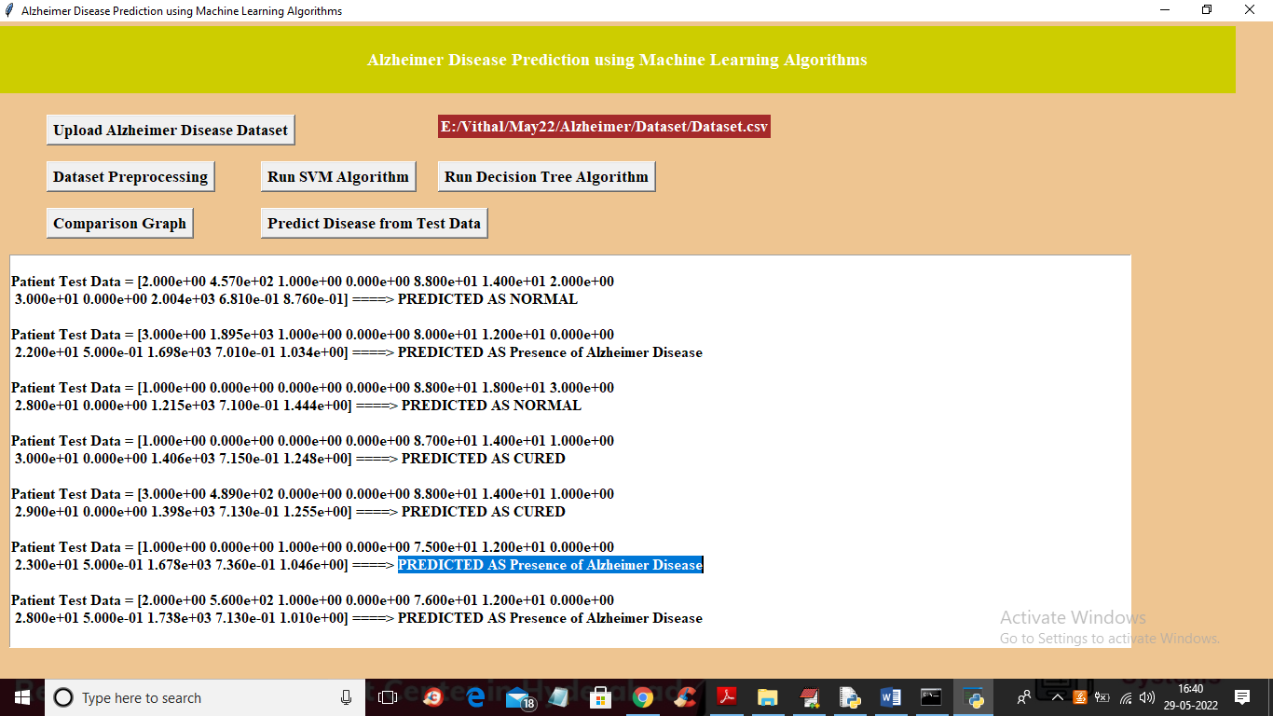
In above screen in square bracket we can see patient test data and after = arrow symbol we can see predicted output as NORMAL or CURED or Presence of Alzheimer disease.
8. CONCLUSION
Machine learning approach to predict the Alzheimer disease using machine learning algorithms is successfully implemented and gives greater prediction accuracy results. The model predicts the disease in the patient and also distinguishes between the cognitive impairment. The future work can be done by combining both brain MRI scans and the psychological parameters to predict the disease with higher accuracy using machine learning algorithms. When they are combined, the disease could be predicted with a higher accuracy in the earlier stage itself

9. REFERENCES
[1] K.R.Kruthika, Rajeswari, H.D.Maheshappa, “Multistage classifier-based approach for Alzheimer’s Disease prediction and retrieval”, Informatics in Medicine Unlocked, 2019. SVM Classifier Decision tree Classifier Performance Comparison (Accuracy) Psychological parameters
[2] Ronghui Ju , Chenhui Hu, Pan Zhou , and Quanzheng Li, “Early Diagnosis of Alzheimer’s Disease Based on Resting-State Brain Networks and Deep Learning”, IEEE/ACM transactions on computational biology and bioinformatics, vol. 16, no. 1, January/February 2019.
[3] Ruoxuan Cuia, Manhua Liu “RNN-based longitudinal analysis for diagnosis of Alzheimer’s disease”, Informatics in Medicine Unlocked, 2019.
[4] Fan Zhang , Zhenzhen Li , Boyan Zhang , Haishun Du , Binjie Wang , Xinhong Zhang, “Multi-modal deep learning model for auxiliary diagnosis of Alzheimer’s disease”, NeuroComputing, 2019.
[5] Chenjie Ge , Qixun Qu , Irene Yu-Hua Gu , Asgeir Store Jakola “Multi-stream multi-scale deep convolutional networks for Alzheimer’s disease detection using MR images”, NeuroComputing, 2019.
[6] Tesi, N., van der Lee, S.J., Hulsman, M., Jansen, I.E., Stringa, N., van Schoor, N. et al, “Centenarian controls increase variant effect sizes by an average twofold in an extreme caseextreme control analysis of Alzheimer's disease”, Eur J Hum Genet. 2019;27:244–253
[7] J. Shi, X. Zheng, Y. Li, Q. Zhang, S. Ying, "Multimodal neuroimaging feature learning with multimodal stacked deep polynomial networks for diagnosis of Alzheimer’s disease", IEEE J. Biomed. Health Inform., vol. 22, no. 1, pp. 173- 183, Jan. 2018.
[8] M. Liu, J. Zhang, P.-T. Yap, D. Shen, "Viewaligned hypergraph learning for Alzheimer's disease diagnosis with incomplete multi-modality data", Med. Image Anal., 2017 vol. 36, pp. 123- 134.
[9] Hansson O, Seibyl J, Stomrud E, Zetterberg H, Trojanowski JQ,Bittner T, “CSF biomarkers of Alzheimer’s disease concordwith amyloid-bPET and predict clinical progression: A study of fullyautomated immunoassays in BioFINDER and ADNI cohorts”. Alzheimers Dement 2018;14:1470–81. [10] Van der Lee SJ, Teunissen CE, Pool R, Shipley MJ, Teumer A,Chouraki V, “Circulating metabolites and general cognitive abilityand dementia: Evidence from 11 cohort studies”, Alzheimer’s Dement2018;14:707–22
[11] Kauppi Karolina, Dale Anders M, “Combining Polygenic Hazard Score With Volumetric MRI and Cognitive Measures Improves Prediction of Progression from Mild Cognitive Impairment to Alzheimer’s Disease”, Frontiers in Neuroscience, 2018.
[12] Grassi M, Loewenstein DA, Caldirola D, Schruers K, Duara R, Perna G, “A clinically-translatable machine learning algorithm for the prediction of Alzheimer's disease conversion: further evidence of its accuracy via a transfer learning approach”, Int Psychogeriatr, 2018 14:1–9. doi: 10.1017/S1041610218001618.
[13] Nation, D.A., Sweeney, M.D., Montagne, A., Sagare, A.P., D’Orazio, L.M., Pachicano, M. et al, “Blood-brain barrier breakdown is an early biomarker of human cognitive dysfunction”, Nat Med. 2019;25:270–276.

